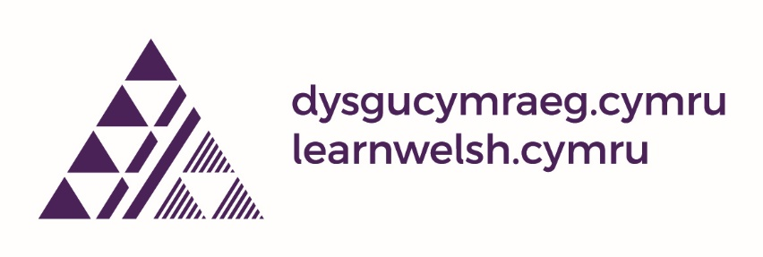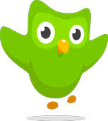
Duolingo – Advice for Dysgu Cymraeg learners
Over the summer, Duolingo have revamped their popular learning app – the first major overhaul in 10 years. This will improve the experience for users (especially on a phone) as the exercises are shorter and more varied with more reinforcement. All users will be moved to this new version over the next few months. However, it does mean that the symbols in the Dysgu Cymraeg textbooks are no longer applicable. Don’t panic!
New Mynediad (Entry) Learners
For learners starting Welsh courses at Mynediad 1, there is no major disruption since the content on the new path more or less follows the content of the class. You can practise the same grammar with different vocabulary. So, just ignore the icons at the end of each unit.
Learners at Mynediad 2, Sylfaen, Canolradd
For users at Mynediad 2, Sylfaen, Canolradd levels who are switched to the new version, one good option is to restart the Welsh course on Duolingo and do the placement test, this is a very good revision of previous topics studied.
If you want to access the units directly, please follow this link: https://duolingo.fandom.com/wiki/Welsh_Tree_Original?fbclid=IwAR0K3xrSxOHaH8PSVBwGhcEhKHbHZp1qvErUSvtbDba11D0N3ik_iuqywy0
You can get more help and guidance on the Facebook page: 'Duolingo Welsh Users - Dysgwyr Cymraeg Duolingo' https://www.facebook.com/groups/welshduolingo
Pob lwc!

