Empanadas o’r Ariannin

Argentine Empanadas
Mae pobl yr Ariannin yn falch iawn o’u empanadas. Mae’n bosib eu llenwi gyda chig o bob math, neu bysgod, llysiau, caws… mae rhywbeth i bawb! Ond rhai cig eidion yw’r rhai traddodiadol. Argentinians are very proud of their empanadas. You can fill them with all kinds of meat or fish, vegetables, cheese … there are fillings for all tastes! But the beef ones are the traditional ones.
Ar gyfer/ for 18 empanada bach/small (tua/around 5 modfedd/inch)

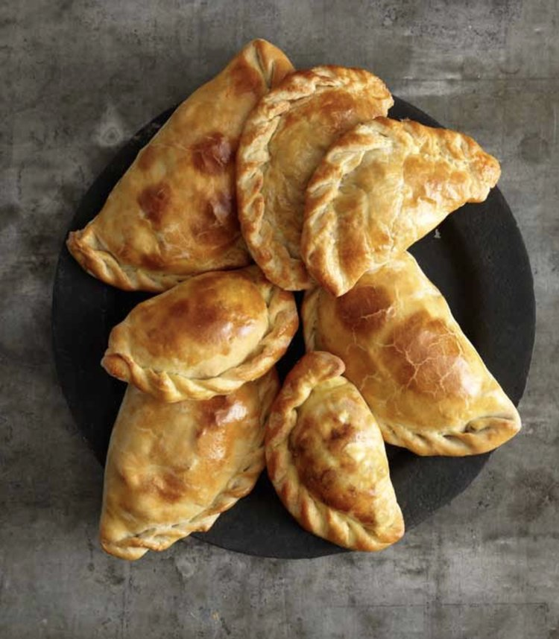
Cynhwysion/ ingredients
1 lb mins cig eidion/minced beef
1 llwy fwrdd/tablespoon olew olewydd/olive oil
1 nionyn wedi ei dorri’n fân/chopped onion
1 pupur coch wedi ei dorri’n fân /chopped red pepper (neu bell peppers bach yn neis!)
Halen a phupur wedi malu/ salt and ground black pepper
½ llwy fwrdd/tablespoon cumin wedi ei falu/ground cumin
1 llwy fwrdd/ tablespoon paprika melys/sweet (pimentón)
1 llwy ffwrdd/tablespoon oregano sych/dried
¼ llwy de/tsp pupur cayenne pepper neu/or chilli powder
1 cwpan/cup stoc cyw iâr/chicken stock
1 llwy de/tsp siwgr/sugar
Llond llaw/handful raisins
1 llwy fwrdd/tablespoon olives gwyrdd/green wedi eu rinsio a’u haneru/rinsed and halved
*Gallu ychwanegu 2-3 wy wedi eu berwi’n galed os liciwch chi/ Can add 2-3 hard-boiled eggs if you like
1 pecyn o does crwst brau neu puff neu’ch crwst eich hun, wedi oeri/ 1 pack of shortcrust or puff pastry, or your own pastry, chilled
Wy wedi ei guro / 1 beaten egg
- Rhowch yr olew mewn padell/sosban fawr ar wres uchel. Ffriwch y cig nes iddo frownio. Codwch gyda llwy dyllog i bowlen. Heat oil on high heat in pan. Fry mince until browned. Use slotted spoon to lift into a bowl.
- Trowch y gwres i lawr i ganolig. Ffriwch y nionyn a’r pupur tan yn feddal ond heb frownio. Ychwanegwch halen a phupur. Turn heat down to medium. Fry onion and pepper until softened. Season.
- Ychwanegwch y cumin, paprika, oregano, cayenne a’u coginio am 1 munud. Add cumin, paprika, oregano, cayenne/chilli and cook for 1 minute.
- Ychwanegwch y stoc a’r cig, yn cynnwys unrhyw sudd. Add stock and meat, including any juices.
- Ychwanegwch y siwgr gyda phupur a halen a choginio’r cwbl, gan ei droi’n gyson, am tua 15-20 munud. Add sugar with more seasoning, and cook for 15-20 mins, stirring often.
- Ychwanegwch y raisins a rhoi’r cyfan mewn powlen, ei orchuddio a’i adael i oeri am o leiaf 3 awr. Add raisins and place mixture in a bowl, cover and leave to cool for at least 3 hrs.
- Tra mae’r llenwad yn oeri, rhowliwch y toes yn denau (3mm) a defnyddiwch soser neu blât i dorri cylchoedd tua 5 modfedd o led. Cadwch nhw yn yr oergell os nad ydach chi am wneud yr empanadas yn syth. While the filling is cooling, roll pastry until thin (3mm) and use saucer/plate to cut out circles around 5 inch wide. Chill (the discs) if you’re not going to assemble the empanadas immediately.
- Brwsiwch ymylon y cylchoedd efo dŵr. Rhannwch y llenwad yn gyfartal a rhoi llwyaid yng nghanol pob un. Plygwch y toes i wneud pestris hanner-lleuad . Brush the edges of the circles with water. Divide the filling equally among the dough rounds, and place a spoonful in the centre of each one. Fold the dough over to make half-moon-shaped pastries.
- Pwyswch yr ymylon at ei gilydd efo blaen eich bys, yna plygwch ymyl y toes drosodd i selio’r empanadas. Neu defnyddiwch fforc. Press the edges of the pastry together with a fingertip, then fold and overlap the edge of the dough to seal the empanadas. Or just use a fork.
- Oerwch yr empanadas, wedi eu gorchuddio’n llac gan blastig tenau, nes dach chi’n barod i’w pobi nhw, hyd at 24 awr. Chill the empanadas, loosely covered with plastic wrap, until you’re ready to bake them, up to 24 hours.
- Trefnwch yr empanadas ar hambwrdd pobi wedi ei leinio â phapur pobi, a golchwch yr wy neu’r llefrith yn ysgafn drostyn nhw. Rhowch nhw mewn popty poeth (400°F/200°C, yna gostyngwch y gwres i 375°F/190°C a’u pobi nes maen nhw’n euraidd – 20 i 25 munud. Arrange the empanadas on a baking sheet lined with parchment and brush lightly with the egg wash/milk. Place in a hot oven (400°F/200°C), then lower the temperature to 375°F and bake until golden, 20 to 25 minutes.
- Oerwch yr empanadas ychydig ar y rac a’u gweini yn gynnes – efallai gyda saws chimichurri. Cool the empanadas briefly on the pan on a rack and serve warm, perhaps with chimichurri sauce.
- Mwynhewch! Enjoy! Bethan Gwanas

